**This is an article about our Skill Development Project-1, which is on Food and Hospitality Management systems. Skill Development Project is a part of our evaluation components, which is assigned to us as a Semester Project by the CSE department, K L University. This project is done as a team of three.**

***Team members:***

***E. kowshik***

***G. Sai Krishna***

***SK. Nasal Afroz***

**In this article, I am going to share my user research and field study of our business system.**

***FIELD VERIFICATION FOR BUSINESS SYSTEM:***

More fieldwork and verification were done by us for the business system.

we noticed that there is a huge growth in the online food delivery system more number of people was preferring online food services

The survey was mainly for taking feedback from customers and the people who are successfully running the hospitality and food services

***INTRODUCTION TO OUR BUSINESS SYSTEM (SDP-1):***

Food Service and Hospitality includes businesses and companies that provide a meal outside the home. This can include companies such as restaurants, cafeterias, catering services, and more. The food service and hospitality industry are one of the largest employers in the United States. The **hospitality** business alone is a several billion dollar industry that profit when disposable income is at its highest.

***(i) PHOTOS DURING MY INTERACTION WITH BUSINESS SYSTEM:***

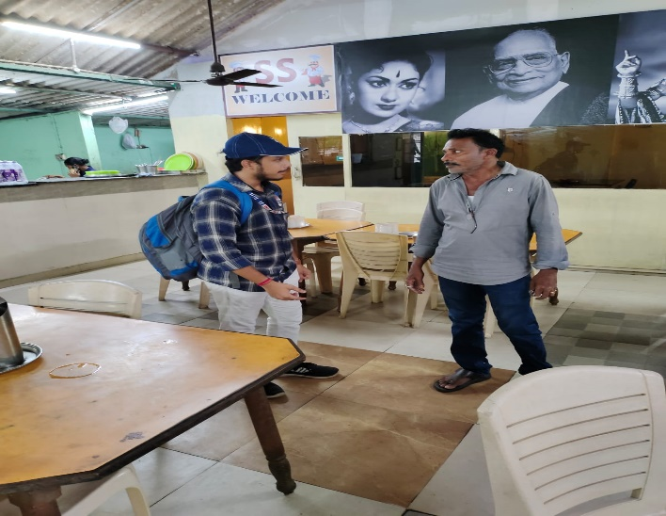

***(ii) FIELD ANALYTICS CHARTS THROUGH SURVEY:***

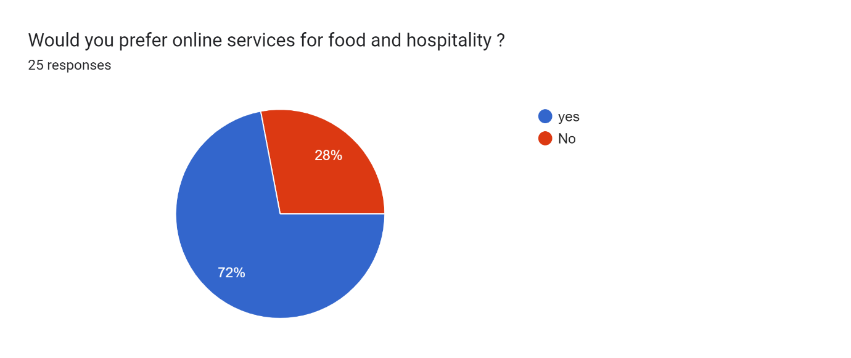

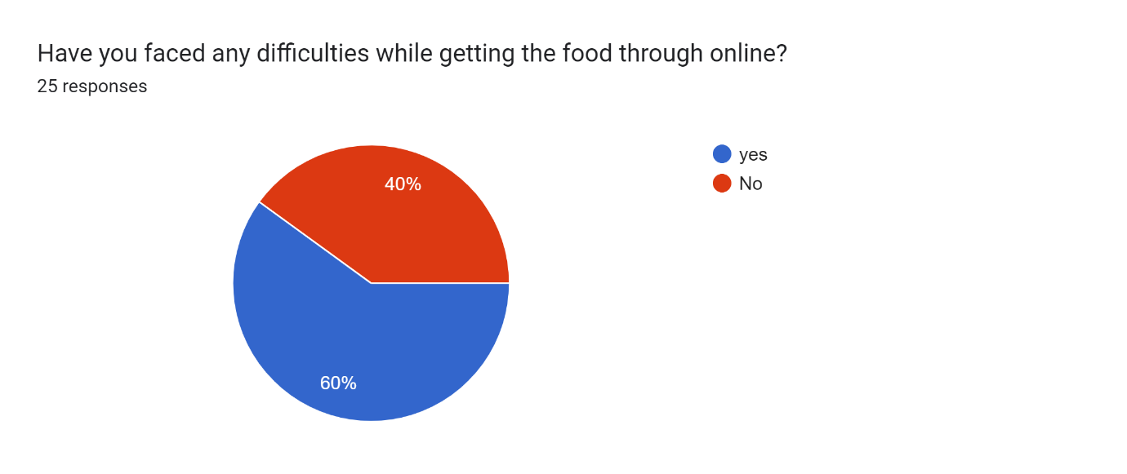

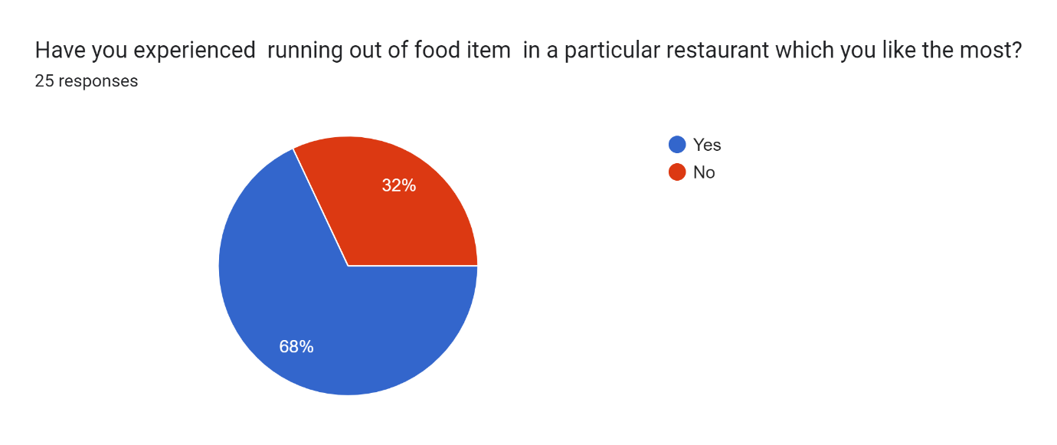

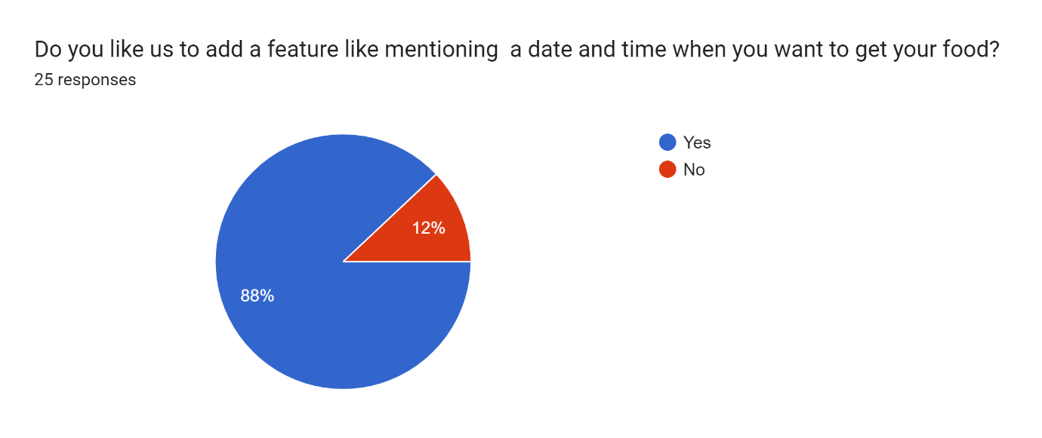

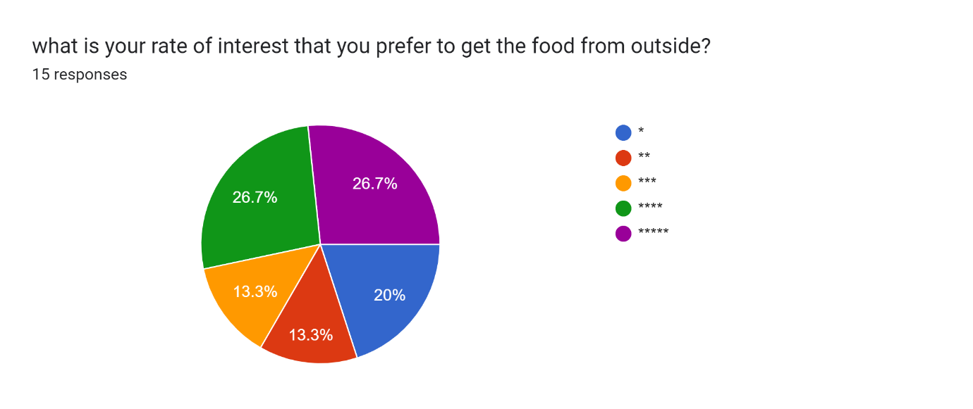

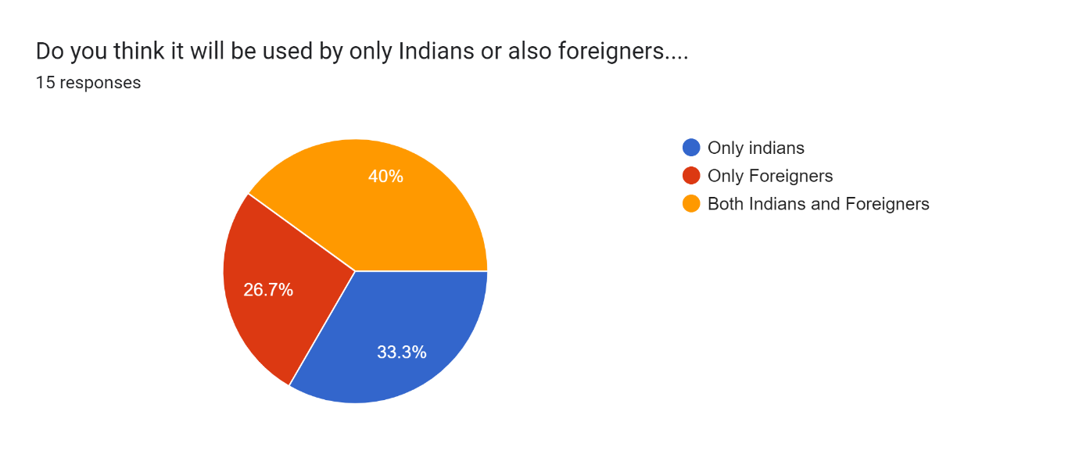

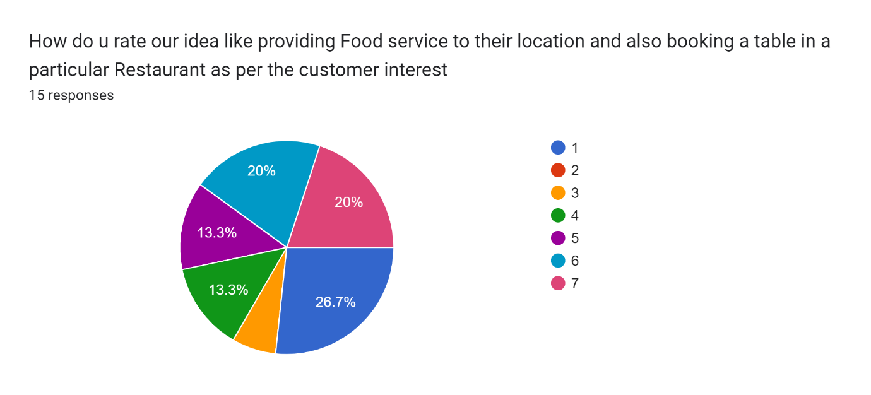

***(iv) ONLINE REFERENCE LINKS:***

1) <https://www.foodhospitality.in/>

2) <https://psu.pb.unizin.org/hmd329/chapter/ch1/>

3) <https://www.hospitalitynet.org/opinion/4088005.html>

**Publicity:**

publicity is the movement of information to the public via media coverage and other non-paid mass media sources. Publicity is not a process but a result of a good public relations strategy where the marketers succeed in providing favourable information to media and other third-party outlets like bloggers, vloggers, podcasters, etc.

It includes so many factors in it. Every day we’ll say a lot of publicity done by many people in different ways like making banners and hoardings, some ads on TV, etc. Publicity can also be done by newspapers which we read every day. The target is to make it reach a lot of people by making them get the total information about what the publishers can give and the customer to get a clear idea. For marketing of any kind of goods or services, publicity is the most required factor, without passing the information to the people, it is not possible to identify the requirement which may lead to loss.

**Marketing:**

Marketing research is the function that links the consumer, customer, and public to the marketer through information—information used to identify and define opportunities and problems; generate, refine, and evaluate actions; monitor performance; and improve understanding of it as a process. It specifies the information required to address these issues, designs the method for collecting information, managing and implementing the data collection process, analyzes the results, and communicates the findings and their implications.

***(v) CUSTOMER JOURNEY MAP:***

**Customer journey** mapping (also called user journey mapping) is the process of creating a customer journey map, a visual story of your customer’s interactions with your brand.

This helps businesses to step into their customer’s shoes and see their business from the customer’s perspective.

Customer journey mapping is a strategic approach for better understanding customer expectations and is crucial for optimizing the customer experience.

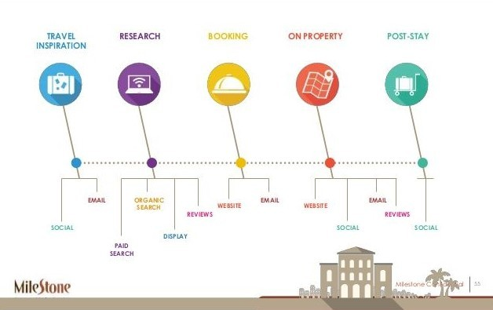

***(vi) USER PERSONA:***

**Persona** is fictional characters, which we create based on our research to represent the different user types that might use our service, product, site, or brand similarly.

Creating Persona will help us to understand users’ needs, experiences, behaviours and goals.

A buyer persona is considering who your customer is. You may or may not have contacted them already. When marketing it is crucial to think about your persona. This will make your marketing the most effective. A buyer persona is a fictitious persona that you create and that corresponds to real people out there.

In the food industry, especially for a small business, creating a buyer persona can be difficult because everyone on Earth eats food. Your success will depend on how specific you can get in the process of building your buyer persona. First thing, consider your product. What kind of food do you sell: American, Italian, Thai, Vegan, gluten-free or keto Are you open 24/7 or do you work a couple of days a week or work on contract?

**Here’s a list of their customer’s characteristics:**

●      Women who stay at home

●      Women who work outside their home

●      Busy families

●      Elderly retired people

●      Single people

●      People who do not know how to cook

●      People who like to take a break from cooking once a week

●      People hosting social events

●      People who like a healthy homemade meal

●      Female or Male

●      People who want to eat healthily

●      Busy people

●      People who want to support a local business

●      People who value entrepreneurs



●      People who like to try new kinds of food

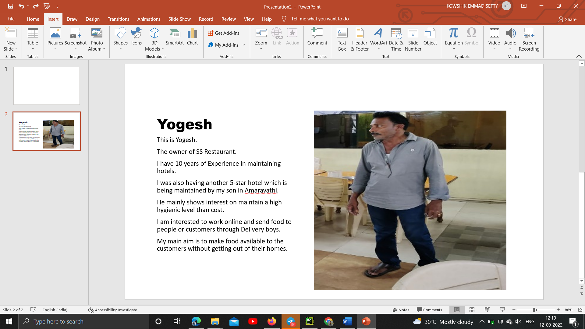



***(vii) MODULES:***

**Home**: This page is nothing but the user interface when the customer opens the website.

**About**: This module redirects the user to the information about our food service business. Users can find every information about the website in this module.

**Menu:** In this module, the user can find the menu offered by us on the website.

**Contact Us**: Here, just in case the user faces any problems like problems on the website or any issues with food, etc he/she can directly contact us to get that particular problem/s solved.

**Sign up:** To offer our services to the users more effectively, we require some information from the customers. So the next time they visit, they don’t need to tell us again where they frequently visit, etc and we can show their previous trips/ orders, etc.

**Login**: Existing users can log in here in this module

**Hotels**: Customers who want to book hotel rooms can do the same in this module.

***(viii) EMPATHY MAP:***

An **empathy map** is a collaborative visualization used to articulate what we know about a particular type of user. It externalizes knowledge about users to 1) create a shared understanding of user needs, and 2) aid in decision making.

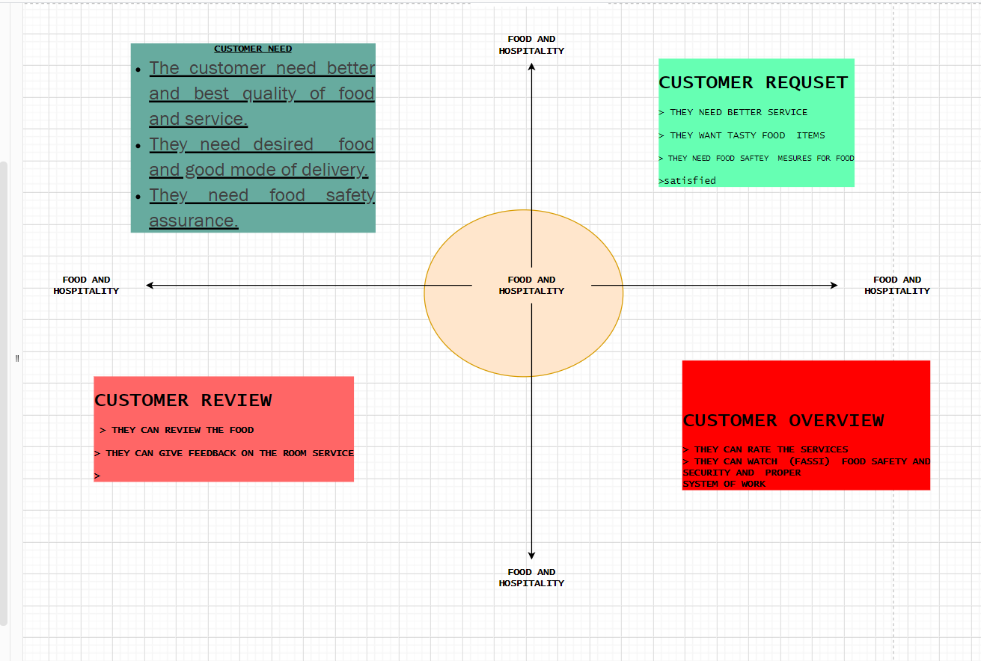

***(ix) AFFINITY DIAGRAM:***

An **affinity** **diagram** is an organized output from a brainstorming session. The affinity diagram helps a group to develop its system of thought about a complex issue or problem. This affinity diagram was created after we(my team) had a brainstorming session.

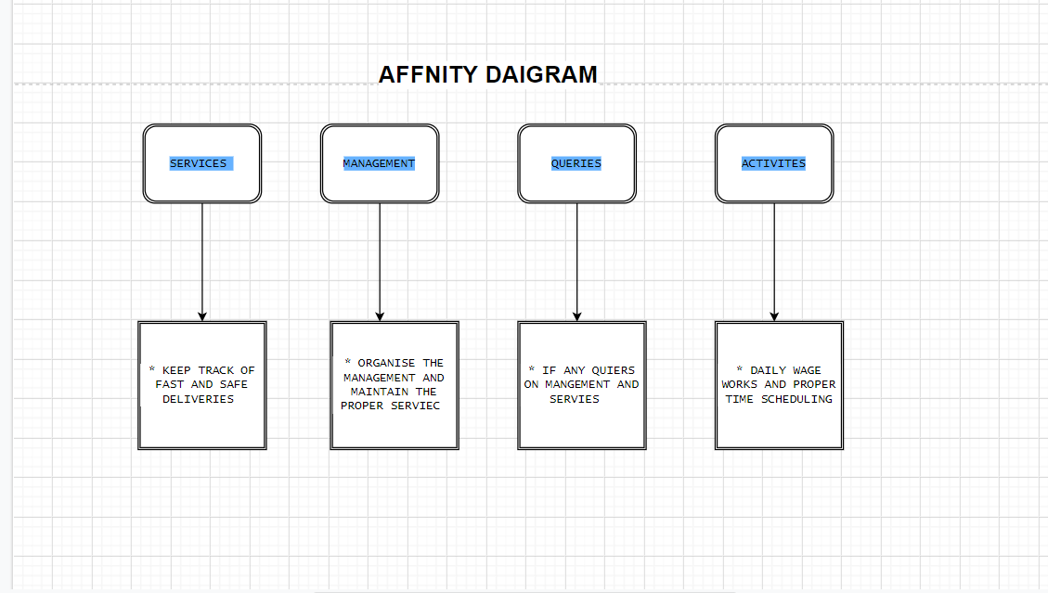

***(x) FINAL USER LIST:***

Business persons, families, Software Employees, People from other states and countries (especially people coming for site seeing and visiting holistic places), travelling persons, students, etc.

***(xi) CONCLUSION:***

Finally, through this article, we got some idea about our business system and the type of end-users. The food and Hospitality sector has tremendous growth in the present world scenario. This is because of urbanization, rising income levels and an improved investment climate. So, through this project, we plan to develop a Food and Hospitality website that fulfils user needs.